Validate Security Certificates (applicable only for point to site and application gateways)

1. Normally Certificate exiry alert will be populated on AWS console
2. Take the screenshot and communicate to the Stake Holders

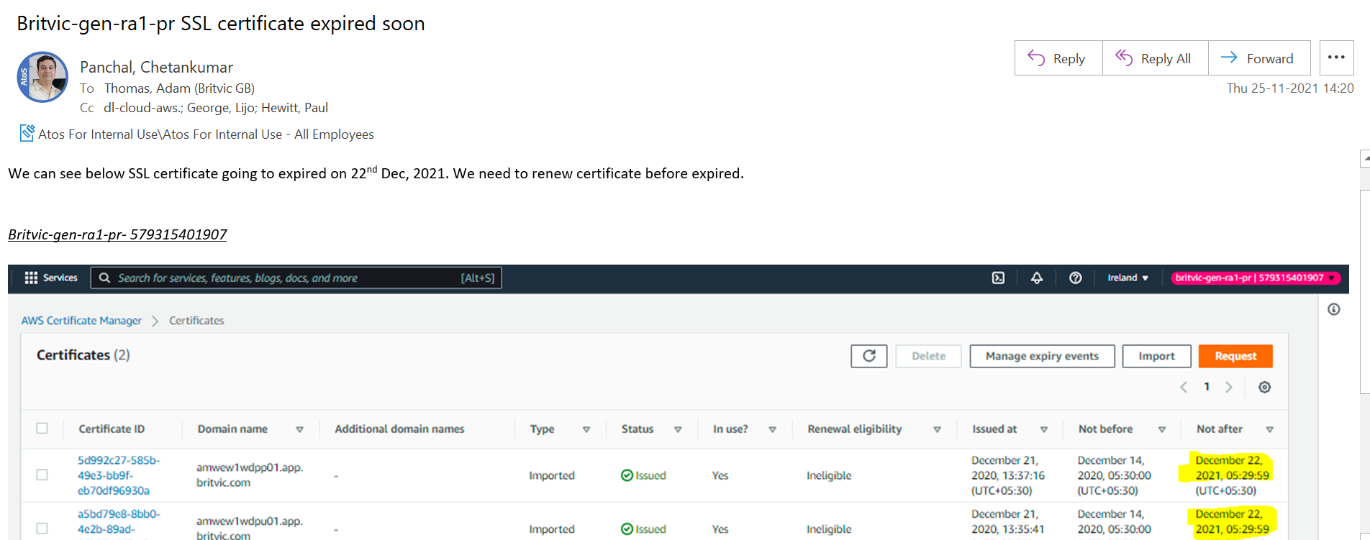

1. Ensure the concern Team is updating this before exiry